**LAPORAN PRAKTIKUM**

**PRAKTIKUM PEMROGRAMAN WEB**

**PERTEMUAN 5**

**RECYCLER VIEW**



Disusun Oleh

Nama : Muchammad Rifqi Chusaini S

NIM : 2300018289

Jadwal praktikum : Selasa 12.15

**PROGRAM STUDI S-1 INFORMATIKA**

**FAKULTAS TEKNOLOGI INDUSTRI**

**UNIVERSITAS AHMAD DAHLAN**

**YOGYAKARTA**

**2025**

# DAFTAR ISI

DAFTAR ISI 2

BAB I PRETEST 3

1.1 Pretest 3

BAB II LANGKAH PRAKTIKUM 4

2.1 Buat new project 4

2.2 Pilih Empty view activity 4

2.3 Masukkan nama file dan lokasinya 5

2.4 Buat struktur finalnya seperti ini 6

2.5 AppExecutor.kt 7

2.6 Barang.kt 7

2.7 BarangAdapter.kt 7

2.8 BarangDao 8

2.9 DatabaseBarang 9

2.10 DetailActivity 10

2.11 MainActivity 11

2.12 Activity_detail.xml 12

2.13 Activity_main.xml 13

2.14 Item_barang.xml 14

2.15 Link Github 14

2.16 Output 15

BAB III POST TEST 16

3.1 Halaman Utama 16

3.2 Tambah Post Baru 17

3.3 Hapus Post 20

3.4 Edit post 22

3.5 Link Github 22

# PRETEST

## Pretest

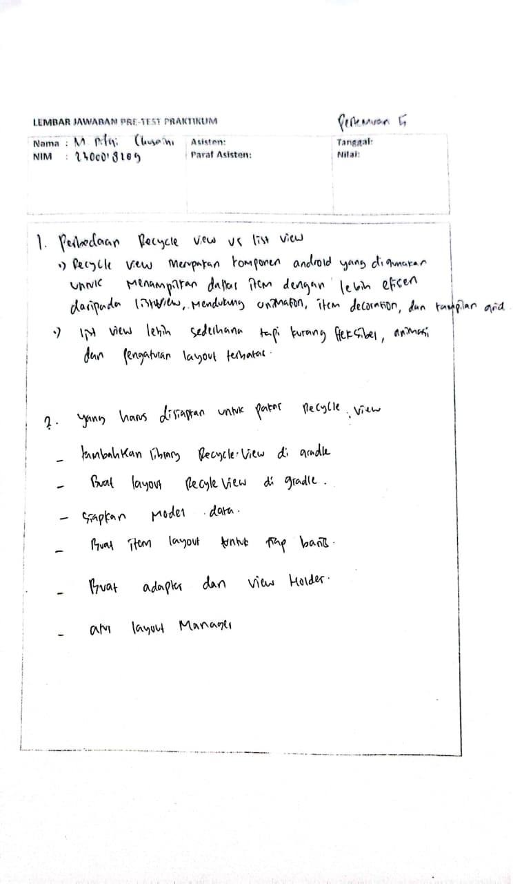

# LANGKAH PRAKTIKUM

## Buat new project

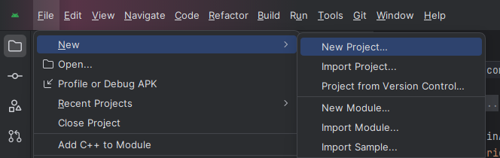

## Pilih Empty view activity

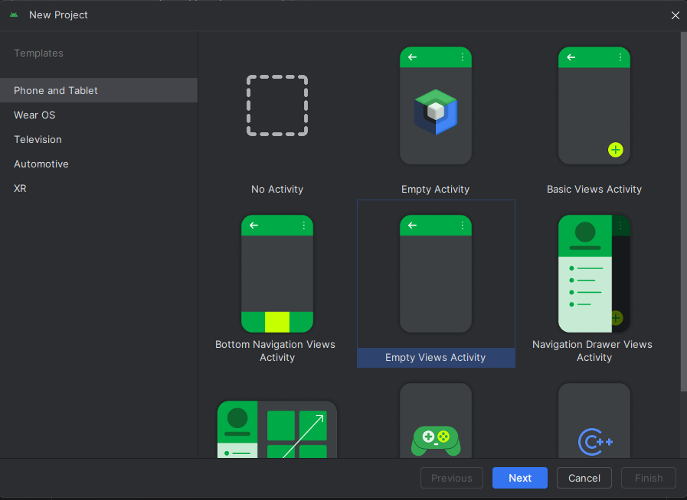

## Masukkan nama file dan lokasinya

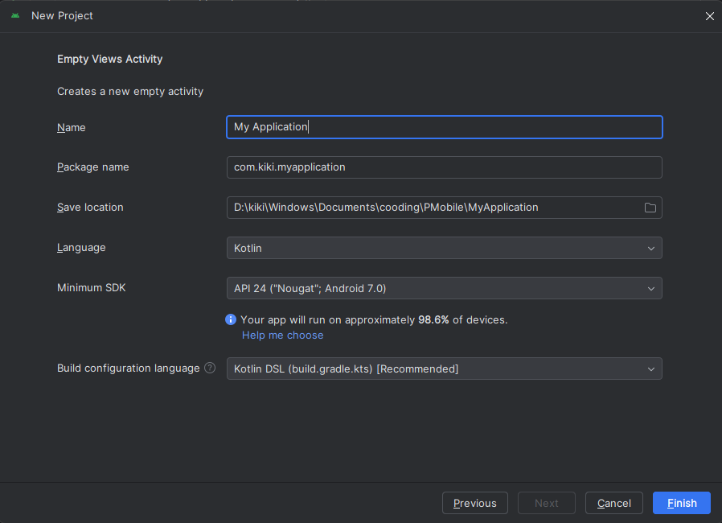

## Buat struktur finalnya seperti ini

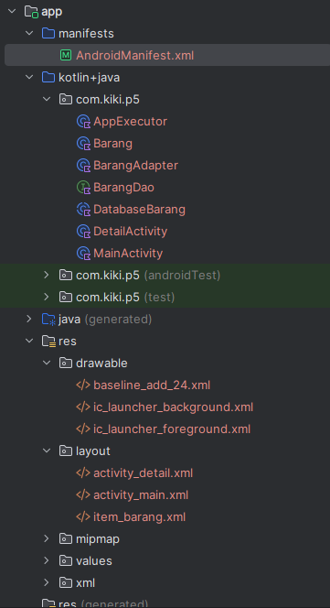

## AppExecutor.kt

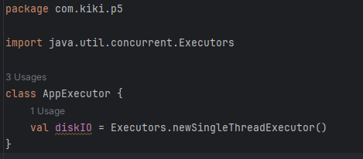

## Barang.kt

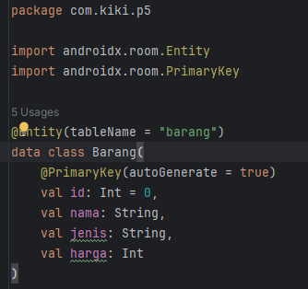

## BarangAdapter.kt

|  |
| --- |
| package com.kiki.p5;  import android.content.Intent import android.view.LayoutInflater import android.view.ViewGroup import androidx.recyclerview.widget.RecyclerView import com.kiki.p5.databinding.ItemBarangBinding   class BarangAdapter(private val barangList: List<Barang>) :  RecyclerView.Adapter<BarangAdapter.BarangViewHolder>() {   override fun onCreateViewHolder(parent: ViewGroup, viewType: Int): BarangViewHolder {  val binding = ItemBarangBinding.inflate(  LayoutInflater.from(parent.*context*),  parent,  false  )  return BarangViewHolder(binding);  }   override fun onBindViewHolder(holder: BarangViewHolder, position: Int) {  val namaBarang = barangList[position]  holder.bind(namaBarang);  }   override fun getItemCount(): Int {  return barangList.size  }   class BarangViewHolder(private val binding: ItemBarangBinding) :  RecyclerView.ViewHolder(binding.*root*) {   fun bind(namaBarang: Barang) {  binding.*apply* **{** tvNama.*text* = namaBarang.nama.toString()  tvJenis.*text* = namaBarang.jenis.toString()   itemView.setOnClickListener **{** val detailIntent = Intent(**it**.*context*, DetailActivity::class.*java*)  detailIntent.putExtra("barang_id", namaBarang.id)  **it**.*context*.startActivity(detailIntent)  **}  }** }  } } |

## BarangDao

|  |
| --- |
| package com.kiki.p5  import androidx.lifecycle.LiveData import androidx.room.Dao import androidx.room.Insert import androidx.room.Query  @Dao interface BarangDao {   @Insert  fun insert(barang: Barang)   @Query("SELECT * FROM barang")  fun getAllBarang(): LiveData<List<Barang>>   @Query("SELECT * FROM barang WHERE id = :id LIMIT 1")  fun getBarangById(id: Int): Barang?  } |

## DatabaseBarang

|  |
| --- |
| package com.kiki.p5  import android.content.Context import androidx.room.Database import androidx.room.Room import androidx.room.RoomDatabase  @Database(entities = [Barang::class], version = 1, exportSchema = false) abstract class DatabaseBarang : RoomDatabase() {   abstract fun barangDao(): BarangDao   companion object {  @Volatile  private var INSTANCE: DatabaseBarang? = null   fun getDatabase(context: Context): DatabaseBarang {  return INSTANCE ?: *synchronized*(this) **{** val instance = Room.databaseBuilder(  context.*applicationContext*,  DatabaseBarang::class.*java*,  "barang_db"  ).build()  INSTANCE = instance  instance  **}** }  } } |

## DetailActivity

|  |
| --- |
| package com.kiki.p5  import android.os.Bundle import androidx.appcompat.app.AppCompatActivity import com.kiki.p5.databinding.ActivityDetailBinding  class DetailActivity : AppCompatActivity() {   private lateinit var binding: ActivityDetailBinding  private lateinit var db: DatabaseBarang  private lateinit var barangDao: BarangDao   override fun onCreate(savedInstanceState: Bundle?) {  super.onCreate(savedInstanceState)  binding = ActivityDetailBinding.inflate(*layoutInflater*)  setContentView(binding.*root*)   // Init database  db = DatabaseBarang.getDatabase(this)  barangDao = db.barangDao()   // Ambil ID barang dari Intent  val barangId = *intent*.getIntExtra("barang_id", -1)   if (barangId == -1) {  binding.tvDetailNama.*text* = "Data tidak ditemukan"  return  }   // Ambil detail barang dari database (Room tidak bisa di main thread → gunakan thread)  Thread **{** val barang = barangDao.getBarangById(barangId)   runOnUiThread **{** if (barang != null) {  binding.tvDetailId.*text* = "ID: ${barang.id}"  binding.tvDetailNama.*text* = "Nama: ${barang.nama}"  binding.tvDetailJenis.*text* = "Jenis: ${barang.jenis}"  binding.tvDetailHarga.*text* = "Harga: Rp ${barang.harga}"  } else {  binding.tvDetailNama.*text* = "Barang tidak ditemukan!"  }  **}  }**.start()  } } |

## MainActivity

|  |
| --- |
| package com.kiki.p5 import com.kiki.p5.databinding.ActivityMainBinding import com.kiki.p5.DatabaseBarang import com.kiki.p5.BarangDao import com.kiki.p5.Barang import com.kiki.p5.AppExecutor   import androidx.appcompat.app.AppCompatActivity import android.os.Bundle import androidx.lifecycle.LiveData import androidx.lifecycle.Observer import androidx.recyclerview.widget.LinearLayoutManager import com.kiki.p5.databinding.ItemBarangBinding   class MainActivity : AppCompatActivity() {   private lateinit var binding: ActivityMainBinding  private lateinit var dbBarang: DatabaseBarang  private lateinit var barangDao: BarangDao  private lateinit var appExecutors: AppExecutor   override fun onCreate(savedInstanceState: Bundle?) {  super.onCreate(savedInstanceState)  binding = ActivityMainBinding.inflate(*layoutInflater*)  setContentView(binding.*root*)   appExecutors = AppExecutor()  dbBarang = DatabaseBarang.getDatabase(*applicationContext*)  barangDao = dbBarang.barangDao()   binding.*apply* **{** fabAdd.setOnClickListener **{** appExecutors.diskIO.execute **{** val barangTitles = *listOf*("Meja", "Semen", "Triplek", "Pasir")  val jenisBarang = *listOf*("Perabotan", "Material", "Material", "Material")  val hargaBarang = *listOf*(50000, 48000, 15000, 68000)   for (i in 1..4) {  val newBarang = Barang(  i,  barangTitles[i - 1],  jenisBarang[i - 1],  hargaBarang[i - 1]  )  barangDao.insert(newBarang)  }  **}  }** val barangList: LiveData<List<Barang>> = barangDao.getAllBarang()   barangList.observe(this@MainActivity, Observer **{** list **->** val layoutManager = LinearLayoutManager(this@MainActivity)  rvRoomDb.*layoutManager* = layoutManager   val adapter = BarangAdapter(list)  rvRoomDb.*adapter* = adapter  **}**)  **}** } } |

## Activity_detail.xml

|  |
| --- |
| <?xml version="1.0" encoding="utf-8"?> <LinearLayout xmlns:android="http://schemas.android.com/apk/res/android"  android:layout_width="match_parent"  android:layout_height="match_parent"  android:orientation="vertical"  android:padding="20dp">   <TextView  android:id="@+id/tvDetailId"  android:layout_width="wrap_content"  android:layout_height="wrap_content"  android:text="ID:"  android:textSize="18sp"  android:padding="4dp" />   <TextView  android:id="@+id/tvDetailNama"  android:layout_width="wrap_content"  android:layout_height="wrap_content"  android:text="Nama:"  android:textSize="18sp"  android:padding="4dp" />   <TextView  android:id="@+id/tvDetailJenis"  android:layout_width="wrap_content"  android:layout_height="wrap_content"  android:text="Jenis:"  android:textSize="18sp"  android:padding="4dp" />   <TextView  android:id="@+id/tvDetailHarga"  android:layout_width="wrap_content"  android:layout_height="wrap_content"  android:text="Harga:"  android:textSize="18sp"  android:padding="4dp" />  </LinearLayout> |

## Activity_main.xml

|  |
| --- |
| <?xml version="1.0" encoding="utf-8"?> <RelativeLayout xmlns:android="http://schemas.android.com/apk/res/android"  xmlns:app="http://schemas.android.com/apk/res-auto"  xmlns:tools="http://schemas.android.com/tools"  android:id="@+id/activity_main"  android:layout_width="match_parent"  android:layout_height="match_parent"  android:padding="16dp">   <androidx.recyclerview.widget.RecyclerView  android:id="@+id/rvRoomDb"  android:layout_width="match_parent"  android:layout_height="wrap_content" />   <com.google.android.material.floatingactionbutton.FloatingActionButton  android:id="@+id/fabAdd"  android:layout_width="wrap_content"  android:layout_height="wrap_content"  android:layout_alignParentBottom="true"  android:layout_alignParentEnd="true"  android:layout_marginEnd="16dp"  android:layout_marginBottom="16dp"  android:src="@drawable/baseline_add_24"  app:fabSize="normal" />  </RelativeLayout> |

## Item_barang.xml

|  |
| --- |
| <?xml version="1.0" encoding="utf-8"?> <androidx.cardview.widget.CardView  xmlns:android="http://schemas.android.com/apk/res/android"  xmlns:app="http://schemas.android.com/apk/res-auto"  android:layout_width="match_parent"  android:layout_height="80dp"  android:layout_marginStart="12dp"  android:layout_marginEnd="12dp"  android:layout_marginTop="8dp"  android:backgroundTint="@color/cardview_light_background"  app:cardCornerRadius="20dp">   <LinearLayout  android:layout_width="match_parent"  android:layout_height="match_parent"  android:gravity="center"  android:orientation="vertical">   <TextView  android:id="@+id/tvNama"  android:layout_width="match_parent"  android:layout_height="wrap_content"  android:layout_marginStart="16dp"  android:layout_marginEnd="16dp"  android:text="Nama barang"  android:textColor="@color/black"  android:textStyle="bold"  android:textSize="18sp" />   <TextView  android:id="@+id/tvJenis"  android:layout_width="match_parent"  android:layout_height="wrap_content"  android:layout_marginStart="16dp"  android:layout_marginEnd="16dp"  android:text="Jenis barang"  android:textColor="@color/black"  android:textSize="16sp" />   </LinearLayout>  </androidx.cardview.widget.CardView> |

## Link Github

<https://github.com/rifqichusaini/Praktikum-Pemrograman-Mobile/tree/main/P5-Recyclerview/Langkah_Prak>

## Output

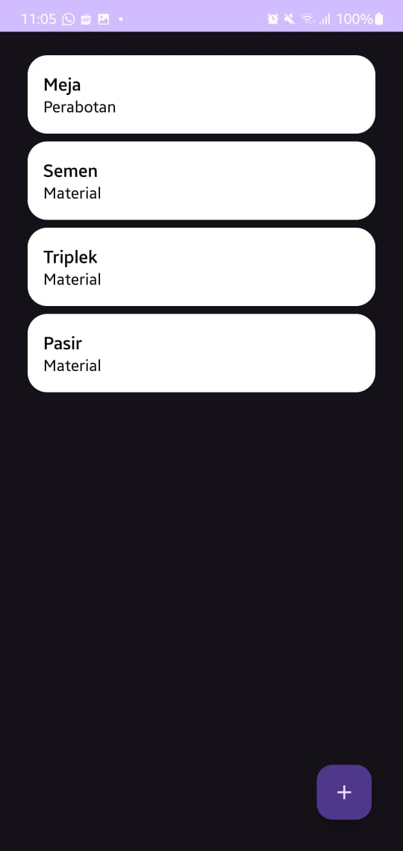

# POST TEST

## Halaman Utama

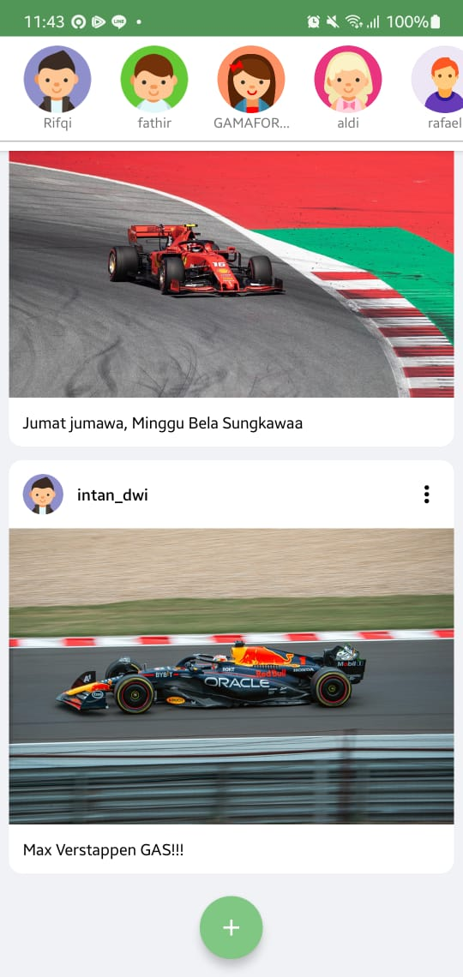

## Tambah Post Baru

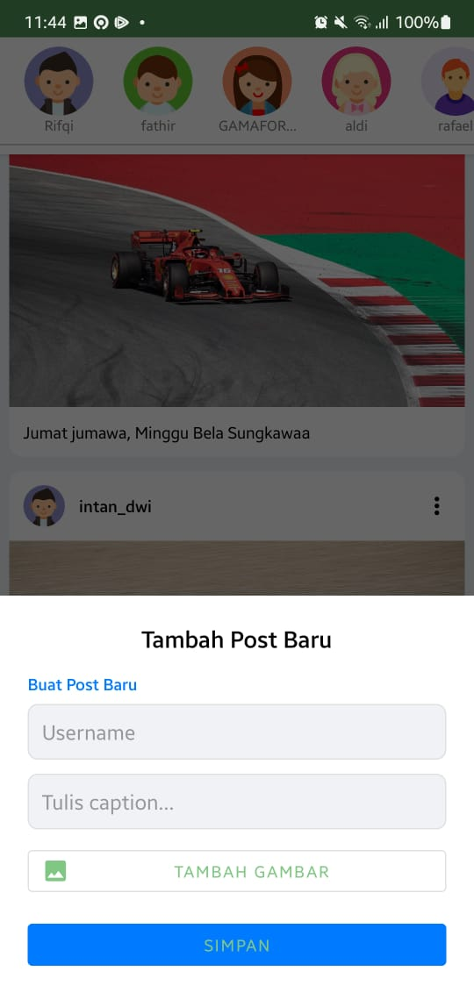

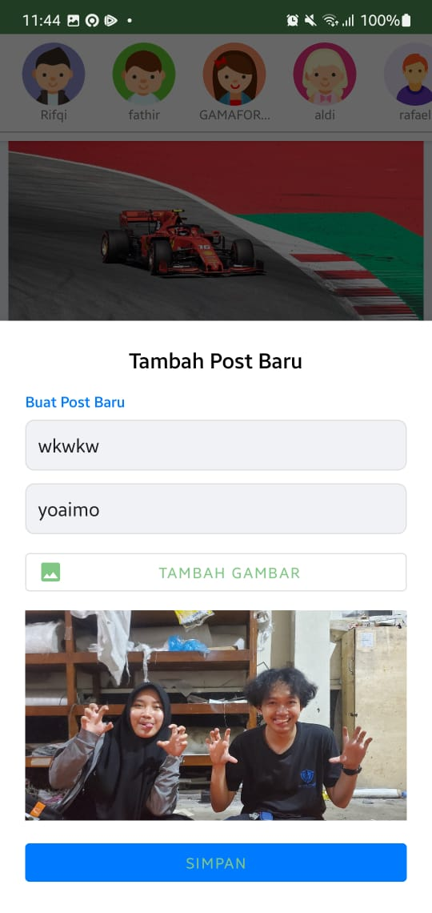

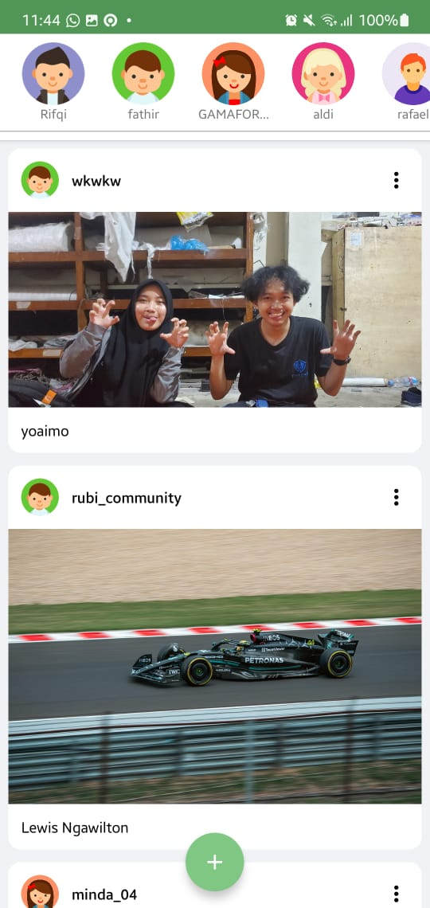

## Hapus Post

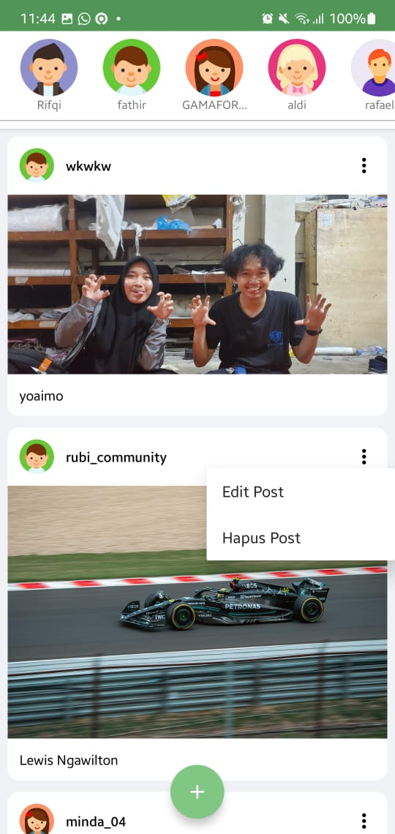

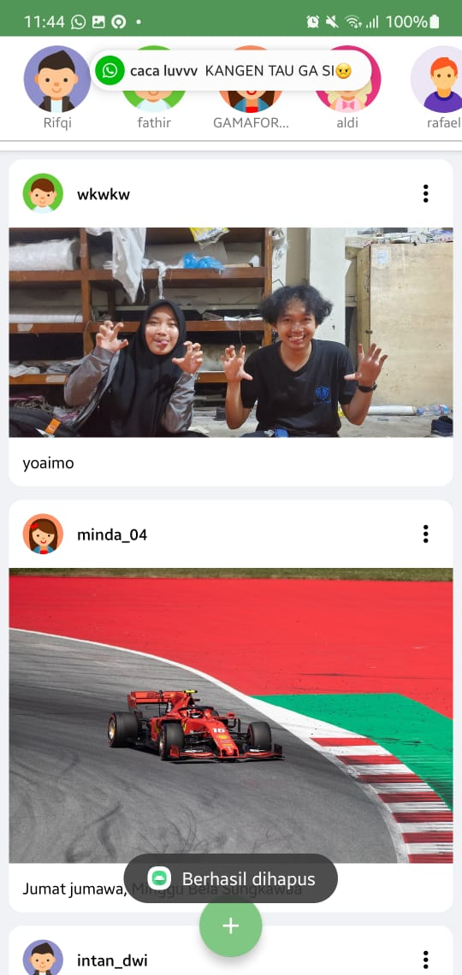

## Edit post

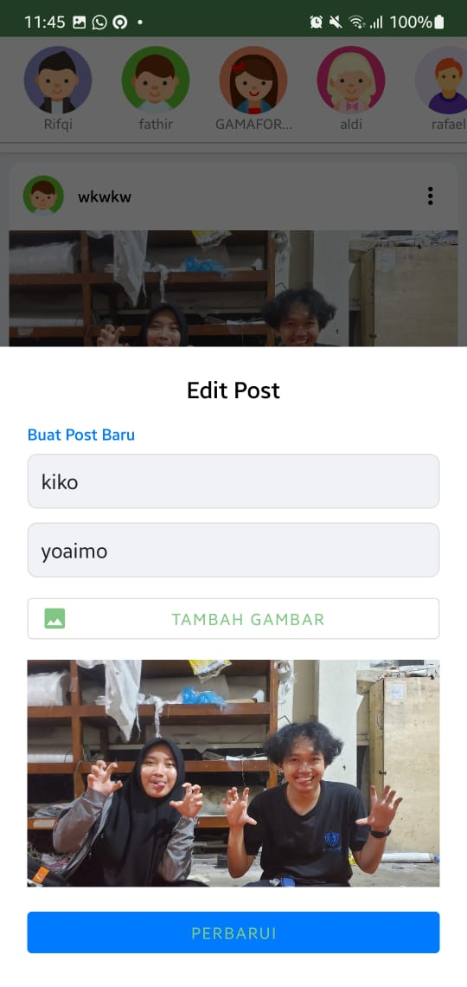

## Link Github

<https://github.com/rifqichusaini/Praktikum-Pemrograman-Mobile/tree/main/P5-Recyclerview/Post>